IALD Presents Merit Award for Monumen Nasional Jakarta
Auviz Lumina Plano Pt. Accepts Award
New York, NY, April 13, 2005 – At its 22nd Annual IALD Awards Presentation, the International Association of Lighting Designers (IALD) is pleased to present an Award of Merit for Monumen Nasional Jakarta, a national monument located in Jakarta, DKI, in Indonesia. The entry was judged in the monumental structures/public spaces category. This year, 15 projects earned awards of merit, and four of them are in the monumental structures/public spaces category. The lighting designer on the project is Abdi Ahsan of Auviz Lumina Plano Pt.
enlarge picture
 | 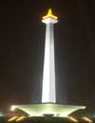 | 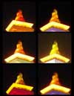 | 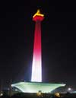 | 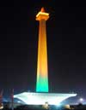
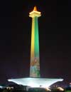 | 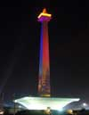 |  | 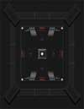
Monumen Nasional is a memorial place, which commemorates Indonesia’s independence and serves as a recreational space for the community. The design challenge was to develop lighting that would serve both the recreational as well as the commemorative roles of the structure. Thus, the memorial lighting was designed with clean, white illumination that created a solemn and graceful presence. Continuously changing, colored floodlights, based on Indonesia’s traditional colors, transformed the top sculpture into a perpetual flame symbolizing the national spirit.
“The design choices are very good,” commented one judge. “It’s a celebration of light.”
At this year’s 22nd annual event, the IALD awarded 23 projects that represented six of the seven categories. The highest point earner wins the Radiance Award for Excellence in Architectural Lighting Design. Fifteen projects earned IALD Awards of Merit, two in both the hospitality and corporate categories, three in the site/façade category, and four in each the retail/entertainment and monumental structures/public spaces categories. Seven IALD Awards of Excellence were also awarded: one in both the corporate and retail categories; two in site/façade; and three in the category of monumental structures/public spaces. An IALD Special Citation for innovative use of materials and techniques for daylighting control was granted for an entry in the academic/institutional category.
The IALD Lighting Design Awards program, established in 1983 and co-sponsored by Professional Lighting Design magazine, honors lighting projects that display high aesthetic achievement backed by technical expertise. Entries are submitted into one of seven categories: Academic/Institutional; Corporate; Hospitality; Monumental Structures/Public Spaces; Residential; Retail/Entertainment; and Site/Façade. Additionally, projects can also be submitted for consideration in the sustainable design award category, which means the project undergoes an additional round of judging keyed solely to the fulfillment of sustainable design principles. A panel of award-winning lighting designers and architects review the projects.
This year, the IALD received 141 submissions from 14 countries. The IALD, established in 1969, is an international organization dedicated to the profession of architectural lighting design. Based in Chicago and comprised of 700 members throughout North and South America, Europe, Asia and Australia, the IALD’s role is to set the global standard for lighting design excellence.
Additional information can be downloaded from www.IALD.org.

